**DATA WAREHOUSING AND MINING – END SEM LAB**

**GOKULNATH S**

**18BCS025**

1. **The dataset selected for the practical is :** Customer Clustering
2. **The kaggle dataset link :**

https://www.kaggle.com/dev0914sharma/customer-clustering

|  |  |
| --- | --- |
| **ATTRIBUTE** | **DATA TYPE** |
| ID | NUMERICAL(DISCRETE) |
| SEX | NUMERICAL(DISCRETE) |
| MARITAL STATUS | NUMERICAL(DISCRETE) |
| AGE | NUMERICAL(DISCRETE) |
| EDUCATION | NUMERICAL(DISCRETE) |
| INCOME | NUMERICAL(DISCRETE) |
| OCCUPATION | NUMERICAL(DISCRETE) |
| SETTLEMENT SIZE | NUMERICAL(DISCRETE) |

**SUPPORTING SCREENSHOTS:**

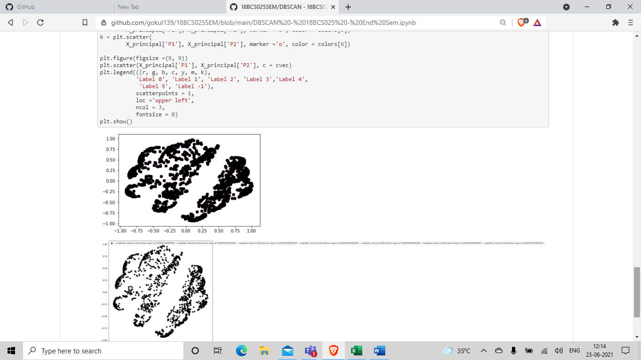

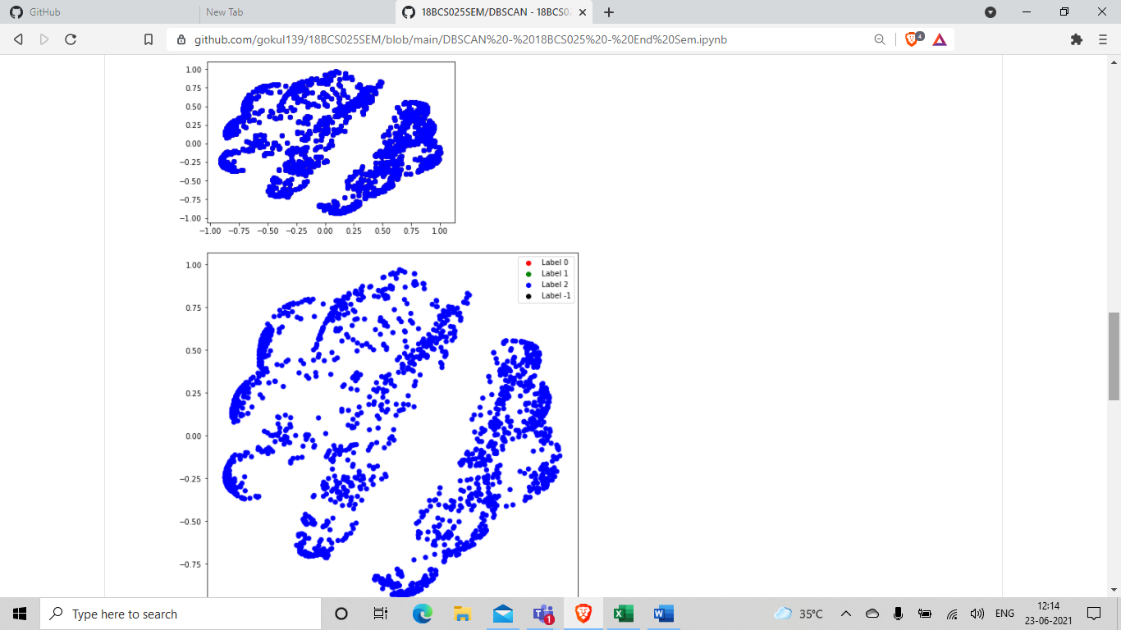

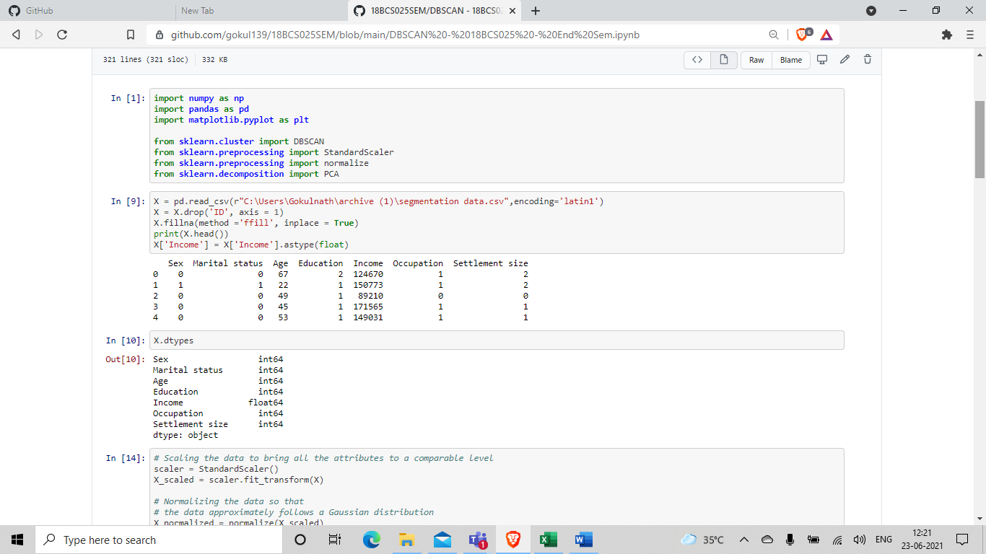

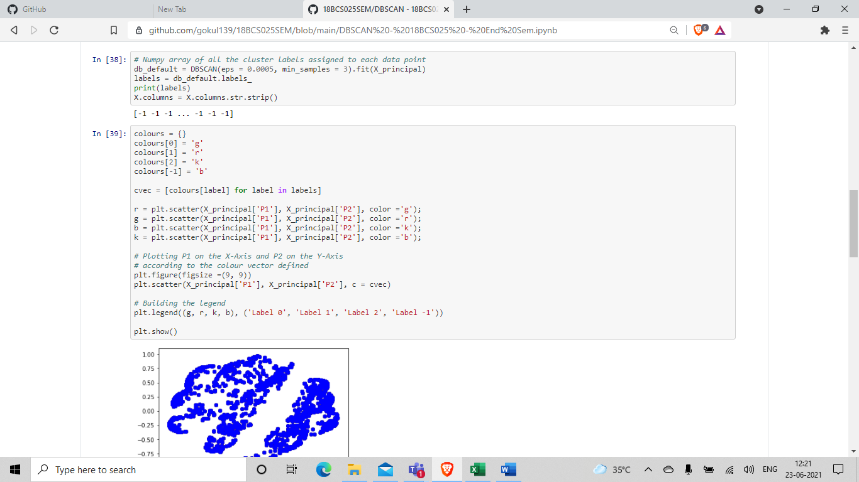

**GITHUB LINK FOR ACCESS:**

<https://github.com/gokul139/18BCS025SEM>